**MAD Termworks**

**Term work – 1**

Develop an application that uses GUI components, Font and Colors.

**Source Code**

**MainActivity.java:**

package com.example.exno1;

import android.graphics.Color;

import android.support.v7.app.AppCompatActivity;

import android.os.Bundle;

import android.view.View;

import android.widget.Button;

import android.widget.TextView;

public class MainActivity extends AppCompatActivity{

int ch=1;

float font=30;

@Override

protected void onCreate(Bundle savedInstanceState){

super.onCreate(savedInstanceState);

setContentView(R.layout.activity_main);

final TextView t= (TextView) findViewById(R.id.textView);

Button b1= (Button) findViewById(R.id.button1);

b1.setOnClickListener(new View.OnClickListener() {

@Override

public void onClick(View v) {

t.setTextSize(font);

font = font + 5;

if (font == 50)

font = 30;

}

});

Button b2= (Button) findViewById(R.id.button2);

b2.setOnClickListener(new View.OnClickListener() {

@Override

public void onClick(View v) {

switch (ch) {

case 1:

t.setTextColor(Color.RED);

break;

case 2:

t.setTextColor(Color.GREEN);

break;

case 3:

t.setTextColor(Color.BLUE);

break;

case 4:

t.setTextColor(Color.CYAN);

break;

case 5:

t.setTextColor(Color.YELLOW);

break;

case 6:

t.setTextColor(Color.MAGENTA);

break;

}

ch++;

if (ch == 7)

ch = 1;

}

});

}

}

**XML Layout**

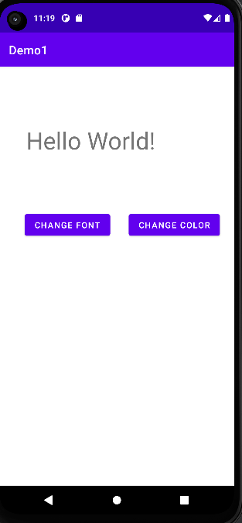

**Term work – 2**

Develop an application that uses Layout Managers and event listeners.

**Creating Second Activity for the Android Application:**

● Click on File -> New -> Activity -> Empty Activity.

● Type the Activity Name as SecondActivity and click Finish button.

● Thus, Second Activity For the application is created.

**Source Code**

**MainActivity.java:**

package com.example.exno2;

import android.content.Intent;

import android.support.v7.app.AppCompatActivity;

import android.os.Bundle;

import android.view.View;

import android.widget.ArrayAdapter;

import android.widget.Button;

import android.widget.EditText;

import android.widget.Spinner;

public class MainActivity extends AppCompatActivity {

//Defining the Views

EditText e1,e2;

Button bt;

Spinner s;

//Data for populating in Spinner

String [] dept_array={"CSE","ECE","IT","Mech","Civil"};

String name,reg,dept;

@Override

protected void onCreate(Bundle savedInstanceState) {

super.onCreate(savedInstanceState);

setContentView(R.layout.activity_main);

//Referring the Views

e1= (EditText) findViewById(R.id.editText);

e2= (EditText) findViewById(R.id.editText2);

bt= (Button) findViewById(R.id.button);

s= (Spinner) findViewById(R.id.spinner);

//Creating Adapter for Spinner for adapting the data from array to Spinner

ArrayAdapter adapter= new ArrayAdapter(MainActivity.this,android.R.layout.simple_spinner_item,dept_array);

s.setAdapter(adapter);

//Creating Listener for Button

bt.setOnClickListener(new View.OnClickListener() {

@Override

public void onClick(View v) {

//Getting the Values from Views(Edittext & Spinner)

name=e1.getText().toString();

reg=e2.getText().toString();

dept=s.getSelectedItem().toString();

//Intent For Navigating to Second Activity

Intent i = new Intent(MainActivity.this,SecondActivity.class);

//For Passing the Values to Second Activity

i.putExtra("name_key", name);

i.putExtra("reg_key",reg);

i.putExtra("dept_key", dept);

startActivity(i);

}

});

}

}

**SecondActivity.java:**

package com.example.exno2;

import android.content.Intent;

import android.support.v7.app.AppCompatActivity;

import android.os.Bundle;

import android.widget.TextView;

public class SecondActivity extends AppCompatActivity {

TextView t1,t2,t3;

String name,reg,dept;

@Override

protected void onCreate(Bundle savedInstanceState) {

super.onCreate(savedInstanceState);

setContentView(R.layout.activity_second);

t1= (TextView) findViewById(R.id.textView1);

t2= (TextView) findViewById(R.id.textView2);

t3= (TextView) findViewById(R.id.textView3);

//Getting the Intent

Intent i = getIntent();

//Getting the Values from First Activity using the Intent received

name=i.getStringExtra("name_key");

reg=i.getStringExtra("reg_key");

dept=i.getStringExtra("dept_key");

//Setting the Values to Intent

t1.setText(name);

t2.setText(reg);

t3.setText(dept);

}

}

**XML Activity**

1) 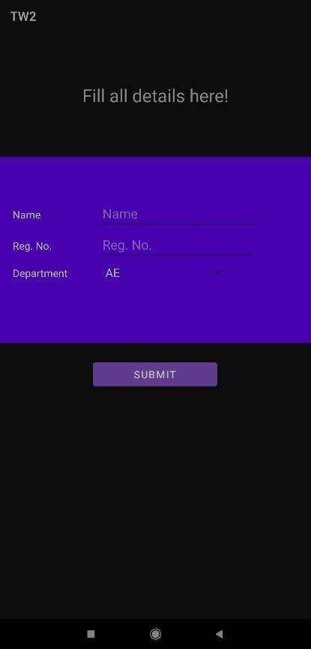 2) 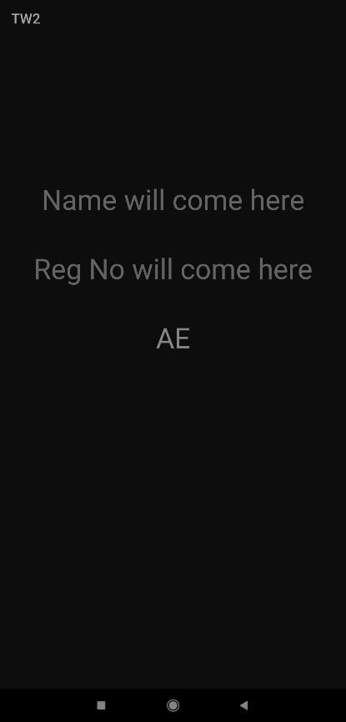

**Term work – 3**

Develop a native calculator application.

**Source Code**

**MainActivity.java**

package com.example.devang.exno3;

import android.os.Bundle;

import android.support.v7.app.AppCompatActivity;

import android.text.TextUtils;

import android.view.View;

import android.view.View.OnClickListener;

import android.widget.Button;

import android.widget.EditText;

import android.widget.TextView;

public class MainActivity extends AppCompatActivity implements OnClickListener{

//Defining the Views

EditText Num1;

EditText Num2;

Button Add;

Button Sub;

Button Mul;

Button Div;

TextView Result;

@Override

public void onCreate(Bundle savedInstanceState){

super.onCreate(savedInstanceState);

setContentView(R.layout.activity_main);

//Referring the Views

Num1 = (EditText) findViewById(R.id.editText1);

Num2 = (EditText) findViewById(R.id.editText2);

Add = (Button) findViewById(R.id.Add);

Sub = (Button) findViewById(R.id.Sub);

Mul = (Button) findViewById(R.id.Mul);

Div = (Button) findViewById(R.id.Div);

Result = (TextView) findViewById(R.id.textView);

// set a listener

Add.setOnClickListener(this);

Sub.setOnClickListener(this);

Mul.setOnClickListener(this);

Div.setOnClickListener(this);

}

@Override

public void onClick (View v){

float num1 = 0;

float num2 = 0;

float result = 0;

String oper = "";

// check if the fields are empty

if (TextUtils.isEmpty(Num1.getText().toString()) || TextUtils.isEmpty(Num2.getText().toString()))

return;

// read EditText and fill variables with numbers

num1 = Float.parseFloat(Num1.getText().toString());

num2 = Float.parseFloat(Num2.getText().toString());

// defines the button that has been clicked and performs the corresponding operation

// write operation into oper, we will use it later for output

switch (v.getId()){

case R.id.Add:

oper = "+";

result = num1 + num2;

break;

case R.id.Sub:

oper = "-";

result = num1 - num2;

break;

case R.id.Mul:

oper = "*";

result = num1 * num2;

break;

case R.id.Div:

oper = "/";

result = num1 / num2;

break;

default:

break;

}

// form the output line

Result.setText(num1 + " " + oper + " " + num2 + " = " + result);

}

}

**XML Activity**

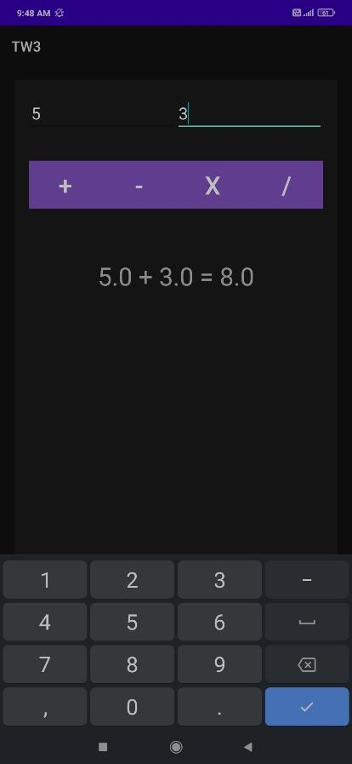

**Term work – 4**

Develop an application that makes use of database.

**Source Code**

**MainActivity.java**

import android.app.Activity;

import android.app.AlertDialog.Builder;

import android.content.Context;

import android.database.Cursor;

import android.database.sqlite.SQLiteDatabase;

import android.os.Bundle;

import android.view.View;

import android.view.View.OnClickListener;

import android.widget.Button;

import android.widget.EditText;

public class MainActivity extends Activity implements OnClickListener

{

EditText Rollno,Name,Marks;

Button Insert,Delete,Update,View,ViewAll;

SQLiteDatabase db;

@Override

public void onCreate(Bundle savedInstanceState)

{

super.onCreate(savedInstanceState);

setContentView(R.layout.activity_main);

Rollno=(EditText)findViewById(R.id.Rollno);

Name=(EditText)findViewById(R.id.Name);

Marks=(EditText)findViewById(R.id.Marks);

Insert=(Button)findViewById(R.id.Insert);

Delete=(Button)findViewById(R.id.Delete);

Update=(Button)findViewById(R.id.Update);

View=(Button)findViewById(R.id.View);

ViewAll=(Button)findViewById(R.id.ViewAll);

Insert.setOnClickListener(this);

Delete.setOnClickListener(this);

Update.setOnClickListener(this);

View.setOnClickListener(this);

ViewAll.setOnClickListener(this);

// Creating database and table

db=openOrCreateDatabase("StudentDB", Context.MODE_PRIVATE, null);

db.execSQL("CREATE TABLE IF NOT EXISTS student(rollno VARCHAR,name VARCHAR,marks VARCHAR);");

}

public void onClick(View view)

{

// Inserting a record to the Student table

if(view==Insert)

{

// Checking for empty fields

if(Rollno.getText().toString().trim().length()==0||

Name.getText().toString().trim().length()==0||

Marks.getText().toString().trim().length()==0)

{

showMessage("Error", "Please enter all values");

return;

}

db.execSQL("INSERT INTO student VALUES('"+Rollno.getText()+"','"+Name.getText()+"','"+Marks.getText()+"');");

showMessage("Success", "Record added");

clearText();

}

// Deleting a record from the Student table

if(view==Delete)

{

// Checking for empty roll number

if(Rollno.getText().toString().trim().length()==0)

{

showMessage("Error", "Please enter Rollno");

return;

}

Cursor c=db.rawQuery("SELECT * FROM student WHERE rollno='"+Rollno.getText()+"'", null);

if(c.moveToFirst())

{

db.execSQL("DELETE FROM student WHERE rollno='"+Rollno.getText()+"'");

showMessage("Success", "Record Deleted");

}

else

{

showMessage("Error", "Invalid Rollno");

}

clearText();

}

// Updating a record in the Student table

if(view==Update)

{

// Checking for empty roll number

if(Rollno.getText().toString().trim().length()==0)

{

showMessage("Error", "Please enter Rollno");

return;

}

Cursor c=db.rawQuery("SELECT * FROM student WHERE rollno='"+Rollno.getText()+"'", null);

if(c.moveToFirst()) {

db.execSQL("UPDATE student SET name='" + Name.getText() + "',marks='" + Marks.getText() +

"' WHERE rollno='"+Rollno.getText()+"'");

showMessage("Success", "Record Modified");

}

else {

showMessage("Error", "Invalid Rollno");

}

clearText();

}

// Display a record from the Student table

if(view==View)

{

// Checking for empty roll number

if(Rollno.getText().toString().trim().length()==0)

{

showMessage("Error", "Please enter Rollno");

return;

}

Cursor c=db.rawQuery("SELECT * FROM student WHERE rollno='"+Rollno.getText()+"'", null);

if(c.moveToFirst())

{

Name.setText(c.getString(1));

Marks.setText(c.getString(2));

}

else

{

showMessage("Error", "Invalid Rollno");

clearText();

}

}

// Displaying all the records

if(view==ViewAll)

{

Cursor c=db.rawQuery("SELECT * FROM student", null);

if(c.getCount()==0)

{

showMessage("Error", "No records found");

return;

}

StringBuffer buffer=new StringBuffer();

while(c.moveToNext())

{

buffer.append("Rollno: "+c.getString(0)+"\n");

buffer.append("Name: "+c.getString(1)+"\n");

buffer.append("Marks: "+c.getString(2)+"\n\n");

}

showMessage("Student Details", buffer.toString());

}

}

public void showMessage(String title,String message)

{

Builder builder=new Builder(this);

builder.setCancelable(true);

builder.setTitle(title);

builder.setMessage(message);

builder.show();

}

public void clearText()

{

Rollno.setText("");

Name.setText("");

Marks.setText("");

Rollno.requestFocus();

}

}

**XML Activity**

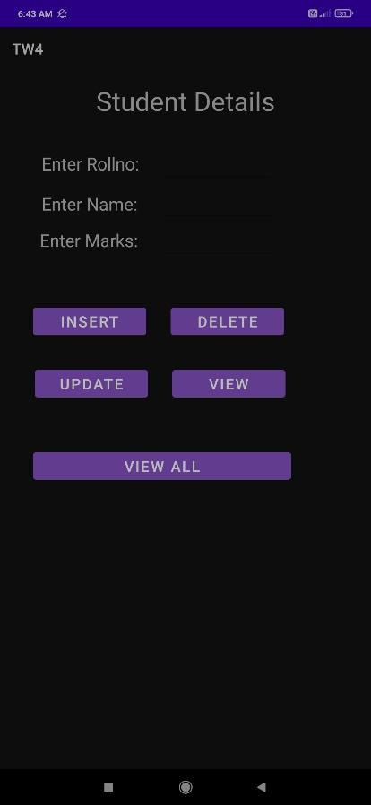

**Term work – 5**

Develop an application that makes use of notification.

**Source Code**

package com.example.notificationdemo1;

import androidx.appcompat.app.AppCompatActivity;

import androidx.core.app.NotificationCompat;

import androidx.core.app.NotificationManagerCompat;

import android.app.NotificationChannel;

import android.app.NotificationManager;

import android.os.Build;

import android.os.Bundle;

import android.view.View;

import android.widget.Button;

import java.nio.channels.Channel;

public class MainActivity extends AppCompatActivity {

Button notifyBtn;

@Override

protected void onCreate(Bundle savedInstanceState) {

super.onCreate(savedInstanceState);

setContentView(R.layout.activity_main);

notifyBtn = findViewById(R.id.notify_btn);

if (Build.VERSION.SDK_INT >= Build.VERSION_CODES.O) {

NotificationChannel channel = new NotificationChannel("My Notification", "My Notification", NotificationManager. IMPORTANCE_DEFAULT);

NotificationManager manager = getSystemService(NotificationManager.class);

manager.createNotificationChannel(channel);

}

notifyBtn.setOnClickListener(new View.OnClickListener() {

@Override

public void onClick(View v) {

NotificationCompat.Builder builder = new NotificationCompat.Builder(MainActivity.this, "My Notification");

builder.setContentTitle("My Notification");

builder.setContentText("This is the notification you received...");

builder.setAutoCancel(true);

builder.setSmallIcon(R.drawable.ic_launcher_background);

builder.setPriority(NotificationCompat.PRIORITY_DEFAULT);

NotificationManagerCompat managerCompat = NotificationManagerCompat.from(MainActivity.this);

managerCompat.notify(1, builder.build());

}

});

}

}

**XML Activity**

